On Demand App :Nearby Service Provider

ABSTRACT
In today’s digital era, where speed and convenience drive user preferences, On-Demand Applications have become essential tools in bridging the gap between service providers and consumers. This project presents an innovative “On-Demand Service Provider App” that empowers users to locate and hire nearby service professionals—such as plumbers, electricians, mechanics, beauticians, and others—directly from their smartphones. The application focuses on eliminating the hassle of searching for trusted providers by offering a centralized platform that connects users with vetted, reliable professionals based on location, service category, and availability.
Customers can easily browse service categories, compare pricing, read reviews, and book services—all with just a few taps. Users can also easily interact with shops, purchase products, and make payments effortlessly through the app. Simultaneously, service providers gain a dynamic platform to showcase their offerings, manage customer requests, and expand their visibility. The system ensures transparency in pricing, timing, and quality assurance by incorporating features such as real-time location updates, ratings, and service history tracking.
By reducing manual effort, streamlining communication, and ensuring a quality experience, the proposed On-Demand Service App redefines how users connect with essential services, making everyday tasks more efficient and stress-free.

Feasibility Study Analysis

1. Project Description
In today’s fast-paced world, users expect services to be accessible instantly and conveniently. The proposed “On-Demand Service Provider App” is a mobile and web-based solution that connects users with nearby, verified professionals like plumbers, electricians, beauticians, mechanics, etc., via a single platform.
The system enhances the user experience by integrating real-time geolocation tracking, service comparisons, and secure payments, while giving service providers the tools to manage requests, showcase portfolios, and grow their client base.

2. Core Features

Geolocation (Maps API Integration)
- Auto-detect user's location.
- Show nearby available service providers.
- Real-time tracking of service delivery.

Machine Learning
- Predict user needs based on past searches and behavior.
- Suggest services, predict pricing based on location/time.

Internet of Things (IoT) Integration
- Real-time updates of service provider movement.
- Smart alerts when a service provider is approaching.

3.Market Feasibility

Market Demand:
- There is a growing demand for fast, reliable, and easily accessible home and personal services in urban and semi-urban areas.
- With increasing smartphone penetration and busy lifestyles, users prefer booking services online instead of traditional phone calls or offline searches.
- Post-COVID-19 behavior changes have increased dependency on digital platforms for essential services like sanitization, plumbing, home repairs, grooming, etc.
- The on-demand home service market in India is projected to reach $3.5 billion by 2025, growing at a CAGR of 18–20%.
- Users increasingly expect features like real-time tracking, verified professionals, and
cashless payment options.
4.Economic Feasibility – Project Description
The economic feasibility of the On-Demand Service Provider App evaluates whether the proposed system can be developed and operated at a cost that is justified by the expected benefits. This app will connect customers with nearby service providers such as plumbers, electricians, cleaners, and technicians, allowing for quick booking, secure payment, and reliable service delivery.
From a financial perspective, the project requires an initial investment for design, development, infrastructure setup, and marketing. which includes app development, cloud hosting, third-party integrations (such as payment gateways and maps), and the first year of operations.
The revenue model is based on multiple income streams, such as commission from service providers, subscription plans, advertisements, and lead generation fees. These revenue sources are projected to generate an average of ₹3.4 lakh to ₹7.3 lakh per month in the early stages, with potential for significant growth as the platform expands to multiple cities.
While there are risks, such as competition and the challenge of acquiring an initial user base, these can be mitigated through strategic marketing, partnerships with local service providers, and the implementation of unique features like AI-driven service recommendations and secure blockchain-based provider verification.

5. Technical Feasibility
This project involves building a full-stack mobile/web application that connects users with local service providers. The system includes modules for users, service providers, and administrators, and incorporates advanced features like geolocation, real-time tracking, machine learning recommendations, and secure authentication.

Technology Stack
Layer | Technology Used
Frontend | Flutter
Backend | Firebase
Location | Maps API / Geolocation API
AI/ML | Python-based microservices via APIs
IoT/GPS | Mobile device sensors for real-time tracking

6. System Requirements & Feasibility

Development Tools Availability
- All development tools (Flutter, Firebase) are open-source and widely supported.
- IDEs like VS Code and Android Studio testing make development easier.
Geolocation Integration
- Feasible using Maps API.
- Mobile devices natively support location tracking (via GPS).

Machine Learning Implementation
- Feasible via lightweight ML models hosted as microservices.
- Can handle tasks like user preference prediction and price estimation.
IoT & Real-Time Tracking
- Real-time tracking of service providers can be implemented using:
  - WebSockets or Firebase Realtime Database
  - Native GPS modules in smartphones (no extra hardware needed)

7. Existing Solution
In the existing system, it can be difficult to find nearby services when needed. Users struggle to find reliable service providers, increasing manual work and difficulty in identifying service details.

8. Disadvantages of Existing System
- Some users may prefer traditional methods like word-of-mouth or online searches.
- Risk of encountering unreliable or unsatisfactory services despite vetting.
- Limited availability of the app in all areas.

9. Proposed Solution
The proposed system offers convenience. Instead of calling multiple providers, users can browse a list of vetted professionals in the app, saving time and ensuring service quality.

10. Advantages of Proposed System
- Easy and quick service search, saving time and effort.
- High-quality services ensured through provider vetting and user rating system.
- Wide range of services, from plumbers to electricians,mechanics, easily accessible.

11. System Modules

Servicer
- Registration
- Login
- My Profile
- Create Services (Name, Price, Category, Description,Service Images,Portfolio Image)
- Update/Delete Services
- My Service Requests (Accept or Reject, View User Map Location)

customer
- Registration
- Login
- My Profile
- Search Nearby Services
- Send Request
- My Request
- Update Geo Location
- Make Payment
- Check Status

Admin
- Login
- Manage Services
- Approve New Services
- Manage Users
- View Services
- Logout

Module Description

Servicer
- Register – Enter basic details to access the application.
- Login – Login to use the app.
- Create Services – Add service name, price, category, description, images, and links.
- Update/Delete Services – Modify or remove services.
- My Service Request – Manage incoming requests; accept/reject and view user location.
- My Profile – Update personal service provider profile.

Administrator
  - Login – Access admin functionalities
  - Profile
  - Manage Sellers – Approve and manage seller details.
  - Manage Users – View and manage registered users.
  - View Services – View all services posted by providers.

Customer
- Register – Sign up for the application.
- Login – Access app features after registration.
- Search Nearby Services – Find providers based on proximity.
- My Request – Request service, update location, and check status.
- My Profile – Manage user account information.

Database Structure

1. Customer Table

Field Name | Type | Description
customer_id (PK) | ObjectId | Unique identifier
Name | String | User full name
Email | String | User email (unique)
password | String | Hashed password
phone | String | Mobile number
location | String | Address or coordinates

Primary Key: user_id

2. Service_Providers Table

Field Name | Type | Description
provider_id (PK) | ObjectId | Unique identifier
Name | String | Provider name
Email | String | Email address
password | String | Hashed password
Phone | String | Contact number
Category | String | General category (plumber, etc.)
Location | String | Provider’s operating area
portfolio_image | String | Optional image URL
Primary Key: provider_id

3. Services Table
Field Name | Type | Description
service_id (PK) | ObjectId | Unique ID for the service
provider_id (FK) | ObjectId | Links to provider
Name | String | Service title
category | String | Plumbing, Electrical, etc.
description | String | Service details
Price | Number | Price in INR
Images | Array | Image URLs
Primary Key: Service_id
Foreign Key: Provider_id → service_providers.provider_id

4. Service_requests Table

Field Name | Type | Description
request_id (PK) | ObjectId | Unique ID of the service request
user_id (FK) | ObjectId | Who made the request
service_id (FK) | ObjectId | Requested service
Status | String | Pending / Accepted / Completed
requested_time | DateTime | Timestamp of request
location | String | Service location
Primary Key: request_id
Foreign Keys:
- customer_id → customer(customer_id)
- service_id → services(service_id)

5. Admin Table

Field Name | Type | Description
admin_id (PK) | ObjectId | Unique ID for admin
Email | String | Admin login email
password | String | Hashed password
Primary Key: admin_id

Payment Table

Field Name | Data Type | Constraints / Description
payment_id | BIGINT (PK) | Unique identifier for the payment transaction.
request_id | BIGINT (FK) | References Request.request_id — links payment to a specific service request.
user_id | BIGINT (FK) | References User.user_id — who made the payment.
servicer_id | BIGINT (FK) | References Servicer.servicer_id — who is receiving the payment.
service_id | BIGINT (FK) | References Service.service_id — service being paid for.
amount | DECIMAL(10,2) | Total transaction amount.
currency | VARCHAR(10) | Currency code (e.g., "INR", "USD").
payment_method | VARCHAR(50) | Method used: UPI, Credit Card, Debit Card, Wallet, Net Banking.
payment_status | ENUM('Pending', 'Completed', 'Failed', 'Refunded') | Current status of the payment.
transaction_id | VARCHAR(100) | Reference from payment gateway (Razorpay, PayPal, etc.).
payment_date | DATETIME | Date and time of payment.
remarks | TEXT | Optional notes (e.g., refund reason, dispute details).
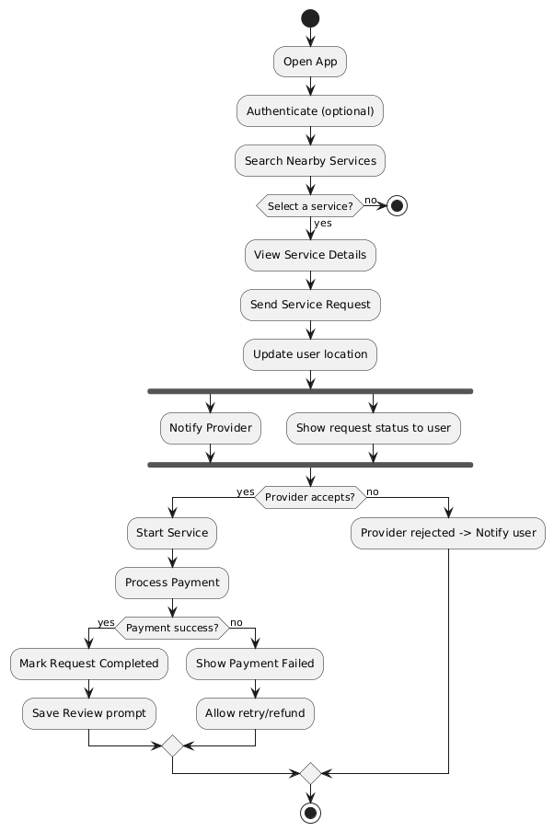
Activity Diagram

CLASS DIAGRAM

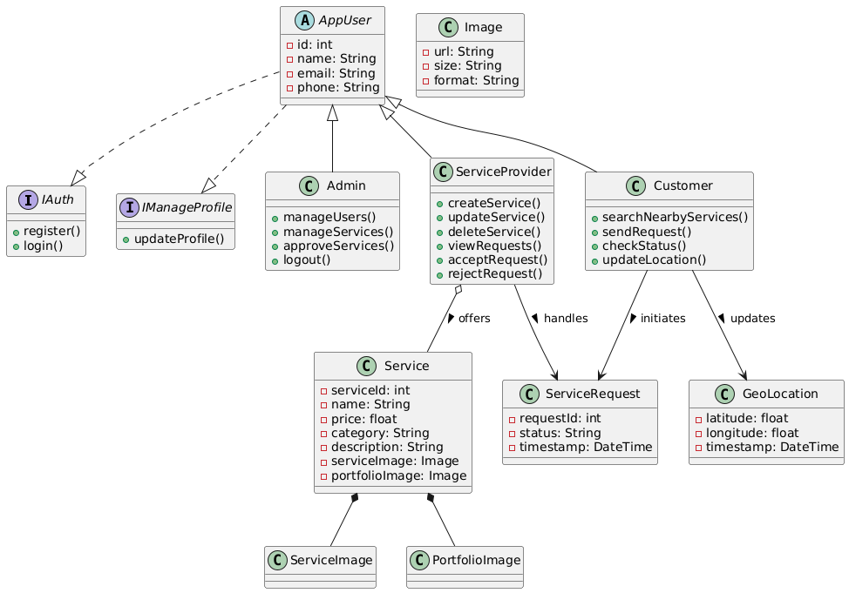

Component Diagram

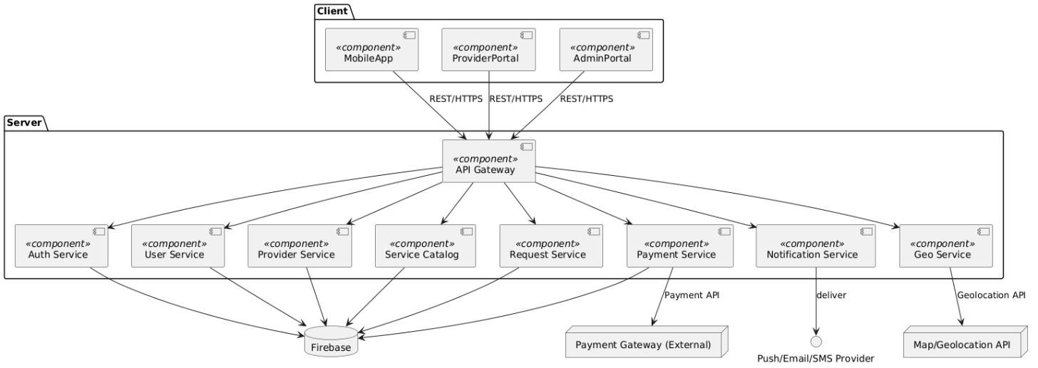

Object Diagram
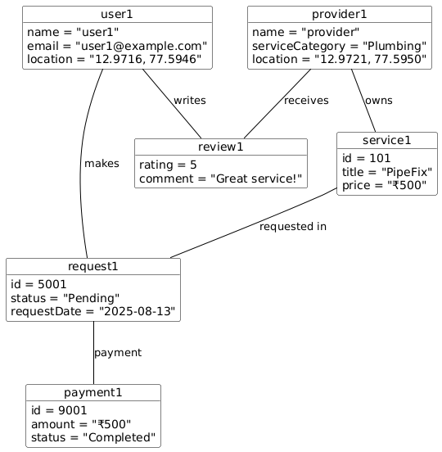
Use Case Diagram
User Module

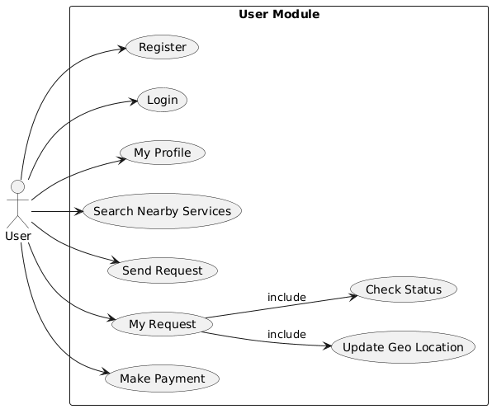

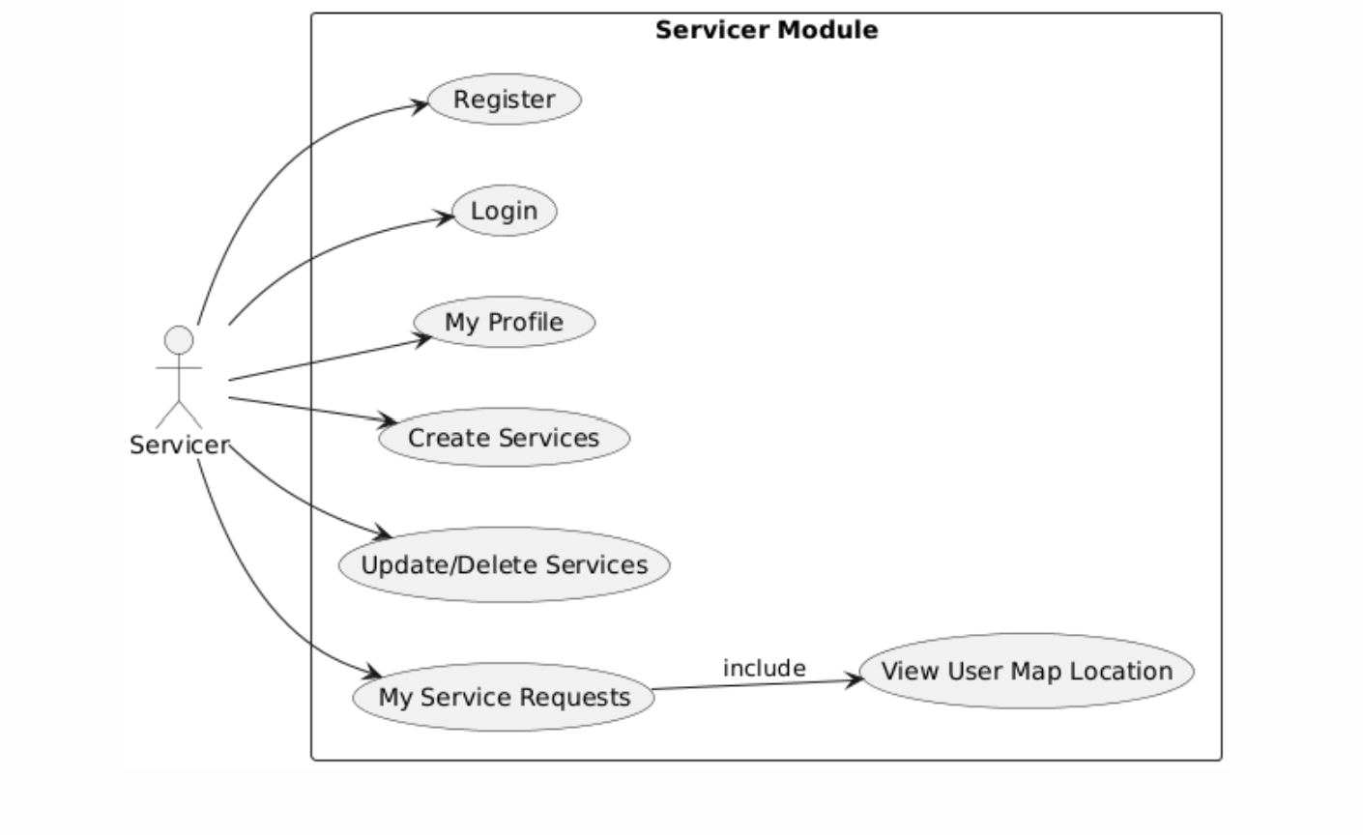
Service Module

Admin Module
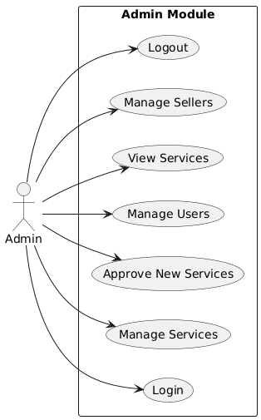

11. Questions & Answers

Q1. Would you be willing to register on an app to reach nearby customers?
Ans:Yes, it would help expand my customer base and reduce the time I spend looking for work.

Q2. Do you currently face difficulties in getting verified or genuine service requests?
Ans: Yes, many leads turn out to be fake or waste time. A verified app system would be very helpful.

Q3. Are you comfortable using a mobile app to manage your services and appointments?
Ans: Yes, I use apps like WhatsApp and PayTM, so using a service app would not be an issue.

Q4. What features would you like to see in such an app?
Ans: Set availability, receive service request notifications, view customer location, and manage
Rating.

Q5. Would having customer reviews and ratings on your profile affect your willingness to use the app?
Ans: No, I believe it builds trust. Good service always gets rewarded.

Q6. Would you pay a small commission or subscription fee for regular, genuine leads?
Ans: Yes, if the app guarantees genuine leads, I would be willing to pay a nominal fee.

Q7. How do you currently promote your service or find customers?
Ans: Mostly through word-of-mouth or local classifieds, but it’s limited in reach.

Q8. Do you have access to a smartphone and basic internet to use the app regularly?
Ans: Yes, I use a smartphone with mobile data daily.

Q9. Do you face challenges in navigating locations or reaching customers on time?
Ans: Yes, sometimes addresses are unclear. Live location from the app would really help.

Q10. Would you prefer cash payments or digital payments (UPI, PayTM, etc.) via the app?
Ans: I prefer digital payments as they are fast and easy to track, but cash option should also be available.

Photos

